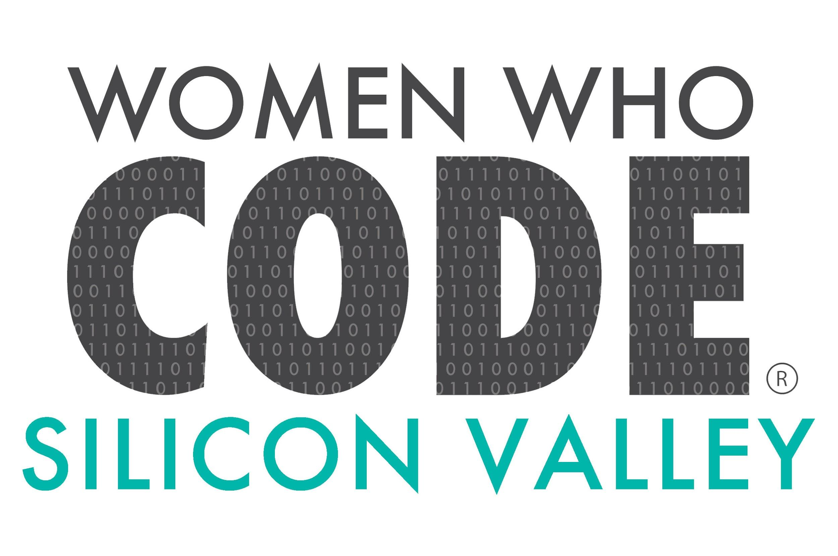
Quarterly Bytes, 2016 Q1
April 11, 2016
Our Silicon Valley chapter of WWCode
was abuzz in the first quarter of 2016.
We had over 40 meetups in 3 months!
Q1 Activity Groups  Android Study Group - Intermediate  Data Science Group  FreeCodeCamp Study Group  Hiking, Tech a Walk  Intermediate iOS/Swift  iOS/Swift Hack Club  Python Hack Club  Ruby On Rails Hack Club  Venture Hack Club | Highlights  iOS/Swift Hack Club finished their first  beginner series, held at Groupon. There  is much interest in future sessions. Stay  tuned, iOS-Swift developers/enthusiasts!  Python Hack Club finished curriculum and voted on a project they are hacking. Contact ketaki.kekatpure@gmail.com if you like to join this Hack Club or slack.
Need Sponsors
We are looking for sponsors to host our events in Q2! Please ask your company about hosting our events. Contributions to WWCode-SV are tax-deductible and come with many benefits. Your company or a representative can fill out a Sponsor form on our weebly site wwcode-sv.weebly.com or notify us: SiliconValley@womenwhocode.com.

News Bits
Mavatar is looking for a female mid-level front-end engineer with 3-5 years experience
in Angular. The job will be part-time (consultant) for 3-6 months, then potentially
full-time. For more info, see the job description at mavatar.com.
Silicon Valley Virtual Reality (SVVR) Expo is happening in San Jose, April 27-29.
If you want to volunteer at the SVVR Expo, complete the SVVR volunteer application.
Knurld is excited to launch a big new hackathon for Web, Mobile (iOS and Android)
and IoT developers. Register for over $34k in cash prizes! PLUS a FREE, cool Hack
T-shirt just for registering. Find out more at knurld.devpost.com.
Getting Involved  WWCode-SV is powered by volunteers!  We are looking for more volunteers/  members to help with graphic design and  the next series of study & hack groups.  Call for volunteers:  - Graphic designers  - Android enthusiasts, intermediate  - iOS/Swift enthusiasts, all levels  We have a slack channel for iOS  #swiftclub! Email yezhisaim@gmail.com  to join #swiftclub on slack. | Sponsors Appreciation  We THANK the following sponsors for supporting WWCode-SV in Q1.  Adaptive Insights, Palo Alto  BMC, Santa Clara  Chegg, Santa Clara  Groupon, Palo Alto  GSV Labs, Redwood City  Hacker Dojo, Mountain View  Knurld, Redwood City  Mavatar, Redwood City  Pivotal Labs, Palo Alto  Plex, Los Gatos  VMware, Palo Alto  Yahoo!, Sunnyvale  Yogatailor, Mountain View  YouthStartup, Palo Alto  Register for kids Summer Camp. Use WWCode-sv to save and to donate to our chapter!

-- WWCode-SV Leadership Group

